### Semester One Examination, 2023

### Question/Answer booklet

# 12 SPECIALIST MATHEMATICS

**UNIT 3**

## Section Two:

## Calculator-assumed

|  |
| --- |
|  |

Your Name

Your Teacher’s Name

## Time allowed for this section

Reading time before commencing work: ten minutes

Working time: one hundred minutes

## Materials required/recommended for this section

***To be provided by the supervisor***

This Question/Answer booklet

Formula sheet (retained from Section One)

***To be provided by the candidate***

Standard items: pens (blue/black preferred), pencils (including coloured), sharpener, correction fluid/tape, eraser, ruler, highlighters

Special items: drawing instruments, templates, notes on two unfolded sheets of A4 paper, and up to three calculators approved for use in this examination

## Important note to candidates

No other items may be taken into the examination room. It is **your** responsibility to ensure that you do not have any unauthorised material. If you have any unauthorised material with you, hand it to the supervisor **before** reading any further.

|  |  |  |  |  |  |
| --- | --- | --- | --- | --- | --- |
| **Question** | **Marks** | **Max** | **Question** | **Marks** | **Max** |
| **7** |  |  | **15** |  |  |
| **8** |  |  | **16** |  |  |
| **9** |  |  | **17** |  |  |
| **10** |  |  | **18** |  |  |
| **11** |  |  |
| **12** |  |  |
| **13** |  |  |
| **14** |  |  |

**Structure of this paper**

|  |  |  |  |  |  |
| --- | --- | --- | --- | --- | --- |
| Section | Number of questions available | Number of questions to be answered | Working time (minutes) | Marks available | Percentage of examination |
| Section One:  Calculator-free | 6 | 6 | 50 | 50 | 34 |
| Section Two:  Calculator-assumed | 12 | 12 | 100 | 97 | 66 |
|  |  |  |  | **Total** | 100 |

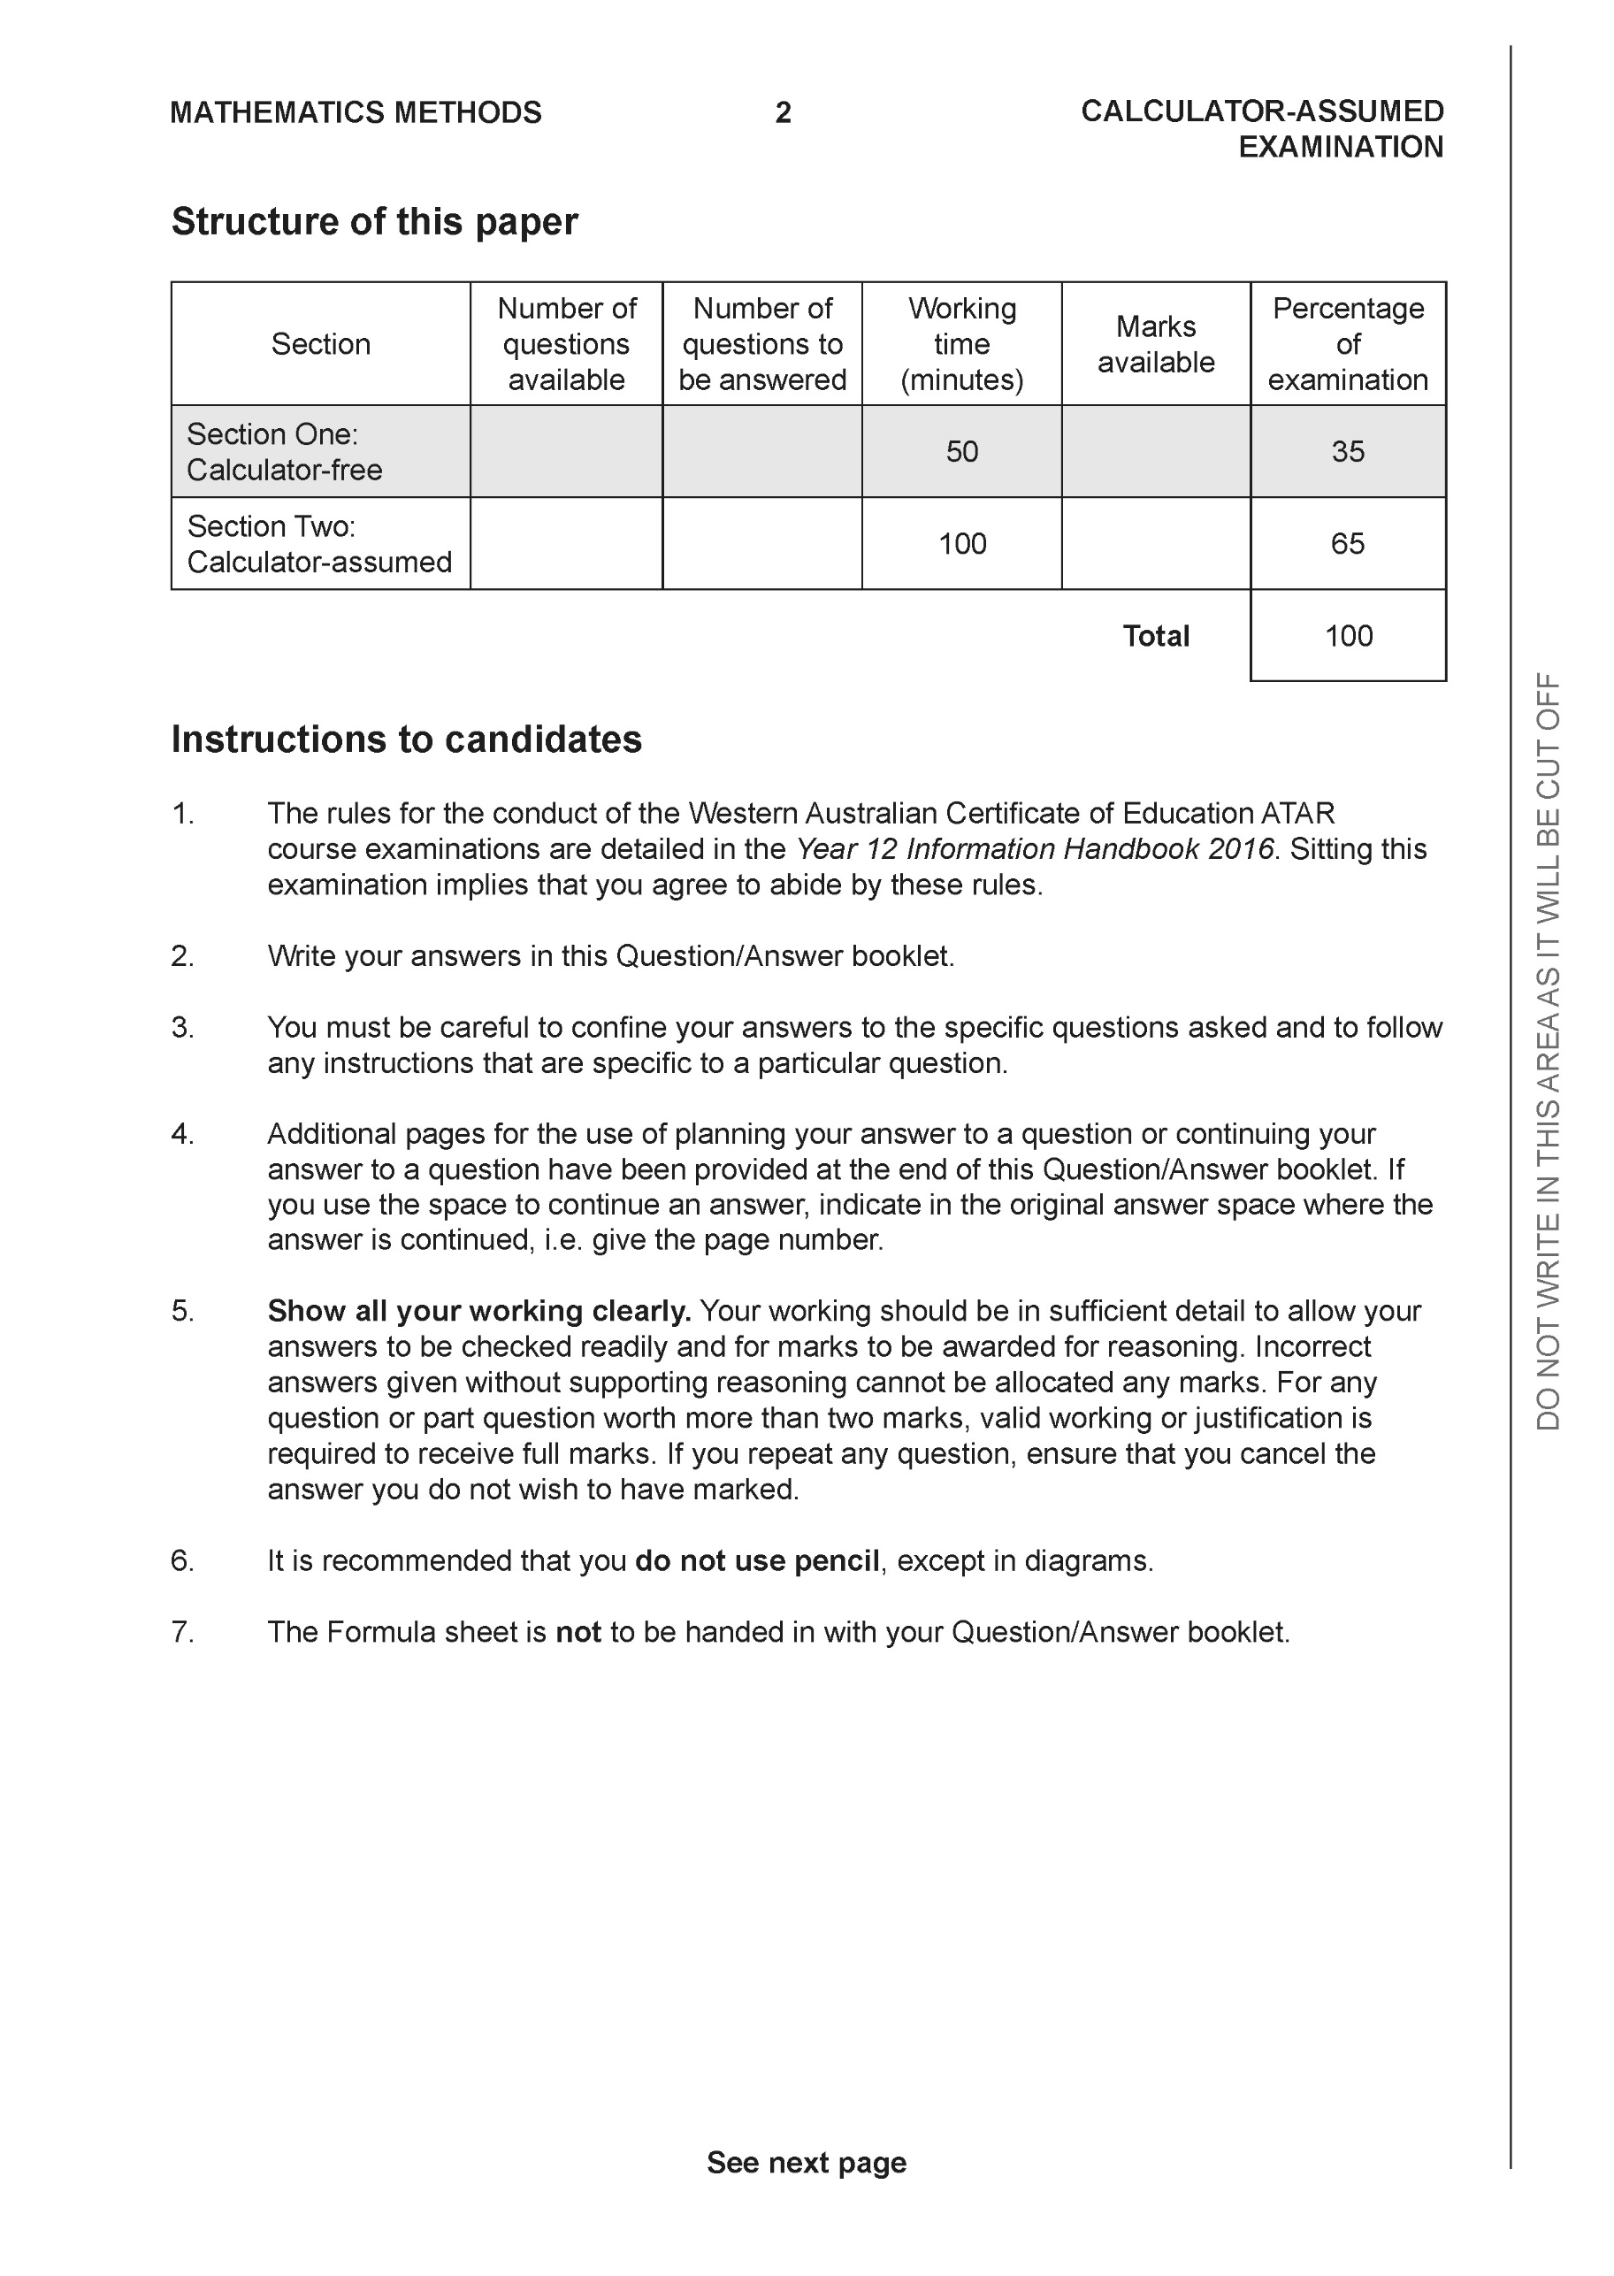

**Section Two: Calculator-assumed (97 Marks)**

This section has **12** questions. Answer **all** questions. Write your answers in the spaces provided.

Spare pages are included at the end of this booklet. They can be used for planning your responses and/or as additional space if required to continue an answer.

● Planning: If you use the spare pages for planning, indicate this clearly at the top of the page.

● Continuing an answer: If you need to use the space to continue an answer, indicate in the original answer space where the answer is continued, i.e. give the page number. Fill in the number of the question that you are continuing to answer at the top of the page.

Working time: 100 minutes.

**Question 7 (5 marks)**

Consider the locus .

1. Sketch the locus on the Argand Diagram below. (2 marks)

|  |
| --- |
| **c** |
|  |
| **Specific behaviours** |
| P centre of circle  P radius |

1. Determine the minimum value of: (3 marks)
2. 
3. Arg

|  |
| --- |
| **c** |
|  |
| **Specific behaviours** |
| P minimum modulus  P argument of centre of circle  P minimum argument, radians or degrees |

**Question 8 (4 marks)**

Consider the plane  and the point A.

Determine the distance of point A from the plane.

|  |
| --- |
| **c** |
| Point B (0,0,-5) |
| **Specific behaviours** |
| P uses normal vector OR line parallel to normal  P uses AB OR solves for line meeting plane  P uses dot product  P determines approx. distance, no need for units |

**Question 9 (9 marks)**

Consider the rectangular box with vertices A(5,0,0), B(5,4,0),C(0,4,0), D(0,4,7), E(5,4,7),F(5,0,7)&G(0,0,7) and the origin.

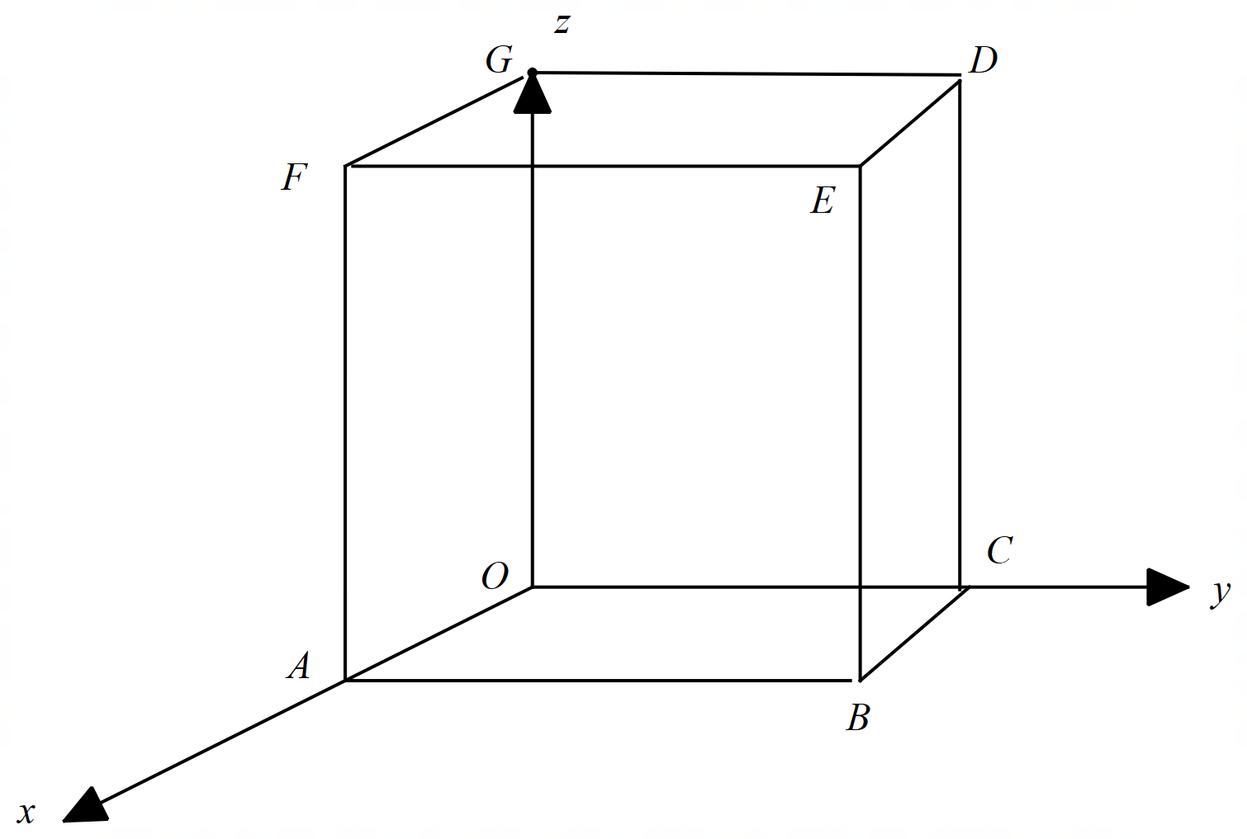

1. If point H divides the diagonal  in the ratio 3:2, determine the position vector .

(2 marks)

|  |
| --- |
|  |
|  |
| **Specific behaviours** |
| P uses correct ratio  P states position vector |

1. Determine the cartesian equation of the plane that contains the points A, G & B.

(4 marks)

|  |
| --- |
|  |
|  |
| **Specific behaviours** |
| P determines two vectors in plane  P uses cross product  P determines vector equation  P determines cartesian equation (no need to simplify) |

1. Prove that the diagonals of the box above, bisect each other using vectors.

(3 marks)

|  |
| --- |
| **c** |
| Let P equal midpoint of diagonal AD  Let Q equal midpoint of diagonal GB |
| **Specific behaviours** |
| P defines midpoints of two diagonals  P determines position vectors of both midpoints  P shows that such position vectors are identical |

**Question 10 (6 marks)**

Consider the complex numbers .

 , Arg

 , 



1. Determine the exact value of  (3 marks)

|  |
| --- |
| **c** |
|  |
| **Specific behaviours** |
| P determines modulus of R  P determines modulus of given values (brackets)  P determines exact modulus of W |

1. Determine the exact value of Arg in Principle form. (3 marks)

|  |
| --- |
| **c** |
|  |
| **Specific behaviours** |
| P determines arg(R)  P determines arg (Q)  P determines arg(W) in principle form |

**Question 11 (6 marks)**

Consider the sphere  , where  is a positive constant, and the line .

Determine all possible values of such that:

1. There is only one point of contact between sphere and line.
2. There are two points of contact between sphere and line.
3. There are no points of contact between sphere and line.

|  |
| --- |
|  |
|  |
| **Specific behaviours** |
| P subs line into sphere vector equation  P determines a quadratic equation with  only  P states an expression for determinant in terms of  only  P states value for one point  P states interval of values for two points  Pstates interval of values for no solns  MAX OF 5 MARKS if students did not note that a is a positive constant |

**Question 12 (6 marks)**

Particles and are moving with constant velocities and have initial positions m and m respectively. seconds later is at m.

(a) Determine the velocity of . (1 mark)

|  |
| --- |
| Solution |
|  |
| Specific behaviours |
| ü correct velocity |

The velocity of is m/s.

(b) Show that the paths of and cross, state the position vector of this point, and explain whether the particles collide. (5 marks)

|  |
| --- |
| Solution |
| For paths to cross we require . Equating and coefficients and solving simultaneously:  Check coefficients are equal with these values of and :  Because , their paths cross at this point and because both particles reach this point at the same time they collide. |
| Specific behaviours |
| ü indicates equations for both paths  ü forms two equations using same or different time parameters(both will work here)  ü solves equations and checks third coefficient  ü correct position vector  ü explains why paths cross and whether particles collide |

**Question 13 (8 marks)**

(a) Determine the equations of all asymptotes of the graph of when

(i) . (2 marks)

|  |
| --- |
| Solution |
| Asymptotes: . |
| Specific behaviours |
| ü horizontal asymptote  ü vertical asymptotes |

(ii) . (2 marks)

|  |
| --- |
| Solution |
| Asymptotes: , . Or |
| Specific behaviours |
| ü oblique asymptote  ü vertical asymptote |

<EFOFEX>
id:fxd{e1b665de-a898-4a08-b32c-b659d84af5de}

FXData:

</EFOFEX>

(b) The graph of is shown  
in the diagram, together with its  
three asymptotes.  
  
The defining rule is given by  
  
 and are positive  
integer constants.  
  
Determine, with brief reasons, the value of and . (4 marks)

|  |
| --- |
| Solution |
| Asymptote .  Root at .  Asymptote .  Asymptote . |
| Specific behaviours |
| üüüü each value with appropriate reason  Max 2 marks if no reasons given with all correct values |

**Question 14 (9 marks)**

<EFOFEX>
id:fxd{b78cbe72-dad2-4e1f-a439-a6fe7385015e}

FXData:
</EFOFEX>(a) Draw the subset of the complex plane determined by on the axes below.

(3 marks)

<EFOFEX>
id:fxd{0d8edfae-a28a-45ab-bf23-5671830d393b}

FXData:

</EFOFEX>

|  |
| --- |
| Solution |
| See diagram |
| Specific behaviours |
| ü indicates points in plane  ü draws perp’ bisector with dotted line  ü shades correct region |

(b) The circular arc in the diagram represents  
the locus of a complex number .  
  
  
Without using or , write  
equations or inequalities in terms of   
for the indicated locus.  
  
  
  
 (3 marks)

|  |
| --- |
| Solution |
| Other possibilities |
| Specific behaviours |
| ü indicates correct centre and radius  ü lower bound for principal argument  ü Upper bound for principal argument |

(c) Describe the subset , or sketch,of the complex plane determined by

.

(3 marks)

|  |
| --- |
| Solution |
| Distance between and in complex plane is .  Hence must lie on the line segment between and inclusive in the complex plane.  Alternatively, when then locus is . |
| Specific behaviours |
| ü indicates or sketches a line  ü indicates or sketches is a line segment  ü indicates or sketches labelled correct end points of line segment |

**Question 15 (8 marks)**

(a) Determine all solutions to the equation in exact polar form. (3 marks)

|  |
| --- |
| Solution |
|  |
| Specific behaviours |
| ü expresses in polar form  ü states one correct solution  ü states all correct solutions |

(b) Consider the seventh roots of unity expressed in polar form .

(i) Determine the roots for which . (2 marks)

|  |
| --- |
| Solution |
| Hence |
| Specific behaviours |
| ü general expression for roots  ü correct roots |

(ii) Use all seven roots to show that . (3 marks)

|  |
| --- |
| Solution |
| The seven roots are given by , and the sum of these roots, and hence their real parts, will be :  But and . Hence |
| Specific behaviours |
| ü uses sum of real parts of all roots is  ü uses and known values  ü sufficient explanation throughout and simplifies to obtain required result |

**Question 16 (15 marks)**

The complex number has been plotted on the Argand diagram below.

<EFOFEX>

id:fxd{f46fdef6-7461-4ebb-8f7c-86afe977dc1e}


FXData:


</EFOFEX>

(a) Express in Cartesian form. (1 mark)

|  |  |
| --- | --- |
| **Solution** | **Specific behaviours** |
|  | * Writes in Cartesian form. |

(b) Express in polar form. (3 marks)

|  |  |
| --- | --- |
| **Solution** | **Specific behaviours** |
|  | * Determines modulus. * Determines argument. * Writes in polar form. |

(c) The complex number is a root of , with the smallest positive argument.

(i) Given that , determine in polar form. (3 marks)

|  |  |
| --- | --- |
| **Solution** | **Specific behaviours** |
|  | * Indicates that . * Uses De Moivre’s Theorem. * Determines in polar form. |

(ii) Determine the remaining roots in polar form. Label the roots as and  
 moving in an anticlockwise direction from the positive real axis. (2 marks)

|  |  |
| --- | --- |
|  | **Specific behaviours** |
|  | * Adds to argument, to determine at least two further solutions. * Determines at least four solutions. |

(d) Determine the exact polar form of . (3 marks)

|  |  |
| --- | --- |
| **Solution** | **Specific behaviours** |
| **<EFOFEX>  id:fxd{f92a5eb3-41a8-4ac8-8b3d-20b1a0a45729}   FXData:  </EFOFEX>** | * Uses vector addition of complex numbers. * Determines modulus of . * Determines argument of . |

, and are roots of .

(e) Determine the values of and . (3 marks)

|  |  |
| --- | --- |
| **Solution** | **Specific behaviours** |
|  | * Uses De Moivre’s Theorem. * Determines . * Determines . |

**Question 17 (12 marks)**

Two parallel mirrors are shown in the diagram below. The larger mirror passes through the origin and is coincident with the plane, and the smaller mirror is in the plane .

<EFOFEX>

id:fxd{8e8486ce-c10d-4609-89a7-20df4454bf4c}


FXData:


</EFOFEX>

A laser beam is fired through a small hole at the origin. The dotted line shows one such beam. The beam then hits the mirror at and is reflected back towards the larger mirror.

The laser beam is pointed with direction .

(a) Determine the position vector of, , the point where the beam hits the smaller mirror.  
 (4 marks)

|  |  |
| --- | --- |
| **Solution** | **Specific behaviours** |
|  | * Determines vector equation of line. * Recognises component is (or substitutes into equation for plane) * Solves for parameter. * Determines position vector of point where beam hits the mirror. |

The laser beam is then reflected with direction .

(b) Determine the position vector of, , the point where the beam hits the larger mirror.  
 (3 marks)

|  |  |
| --- | --- |
| **Solution** | **Specific behaviours** |
|  | * Determines vector equation of line. * Solves for parameter, or recognises connection with parameter in part (a). * Determines position vector of point where beam hits the mirror. |

A second beam is fired from the origin with a direction of . When it hits the smaller mirror, it is then reflected with direction of . You may assume that the speed of the beam does not change.

There are laser beams from the origin which after being reflected in the small mirror do not hit the larger mirror.

(c) Determine the range of values of and , that ensure the beams **are reflected** in  
the larger mirror. (5 marks)

|  |  |
| --- | --- |
| **Solution** | **Specific behaviours** |
|  | * Determines location where the beam hits the small mirror. * Determines range of and so beam hits the small mirror. * Uses , and determines location where the beam hits the larger mirror. * Determines range of . * Determines range of .   [Award at most 3/5 if final range for is and no calculation included for beam to hit small mirror.] |

**Question 18 (9 marks)**

The graph of is shown with a dotted curve on the axes below.

<EFOFEX>

id:fxd{94a2eda1-8b9d-4b74-b6e8-5dc46eff3207}


FXData:


</EFOFEX>

(a) On the same axes draw the graph of . (4 marks)

**<EFOFEX>

id:fxd{288e905b-1742-468f-b95b-f7212835e37f}


FXData:

</EFOFEX>**

|  |
| --- |
| **Specific behaviours** |
| * Section drawn correctly. (shape and asymptotic behaviour) * Section drawn correctly.   (shape and asymptotic behaviour – accept if correct from -1 to 1)   * Section drawn correctly.   (shape and asymptotic behaviour)   * Curve passes through at least 2 of , and . |

(b) (i) The equation has solutions for what range of values of ? (2 marks)

|  |  |
| --- | --- |
| **Solution** | **Specific behaviours** |
|  | * Determines lower boundary. * Determines upper boundary.   [do not penalize instead of ] |

(ii) Does the equation ever have solutions? (1 marks)

|  |  |
| --- | --- |
| **Solution** | **Specific behaviours** |
|  | * States no. |

(c) Determine the solutions to . (2 marks)

|  |  |
| --- | --- |
| **Solution** | **Specific behaviours** |
|  | * States . * States .   [Award at most 1 FT mark if answer of ‘no solutions’ given and is consistent with graph.] |

Q18 continued

Additional working space

Question number:

Additional working space

Question number:

Additional working space

Question number: